Solution design document template

Step 3: Outline the solution and plan

1. Document control
Version | Date | Author | Change Description
v1.0 | April 26, 2026 | Business Analyst | Initial draft of the Strategic Solution Proposal including SWOT and SMART goals.
v1.1 | April 27, 2026 | Business Analyst | Integration of SAP GTS/SAC technical requirements and risk mitigation strategies.
v1.2 | April 28, 2026 | Project Lead | Finalized RACI matrix and high-level implementation roadmap for Executive review.

2. Problem statement
Current situation:
- The U.S. government has imposed tariffs of 15% to 25% on imported manufacturing components, specifically semiconductors and steel casings.
- Key trading partners, including the European Union and China, have responded with reciprocal tariffs that affect U.S. exports.
- Our organization operates a global supply chain with production facilities primarily based in Asia, making it highly vulnerable to these tariff shifts.
- The current procurement process lacks digital visibility, leading to incomplete tracking of tariff-adjusted landed costs.
Business needs: Mitigate financial risks and preserve profit margins by reducing the impact of import duties on the landed cost per unit.
Re-evaluate and diversify sourcing strategies to decrease dependency on high-tariff regions.
Implement business analysis enhancements, such as SAP Analytics Cloud (SAC) dashboards, to gain real-time visibility into cost volatility.
Maintain global competitiveness and market share despite an increasingly protectionist trade environment.
Constraints: The supply chain realignment must be completed within a strict 90-day assessment and execution window.
The organization has limited short-term flexibility to change existing suppliers or modify production lines immediately.
Proposed changes must align with current global trade regulations to avoid legal risks and penalties.
Assumptions: Existing trade agreements, such as the USMCA for Mexico-based production, will remain stable during the 18-month transition phase.
The current SAP S/4HANA backbone is compatible with the required GTS and SAC system updates without requiring a full-scale overhaul.
Qualified alternative manufacturing partners in non-tariffed zones (e.g., Vietnam and Mexico) are available and capable of meeting technical standards.
Executive leadership will provide the necessary sponsorship and rapid decision-making authority to meet the 10-week implementation roadmap.
Based on the strategic documents and analysis, here is the structured Solution Overview for your design document:

3. Solution Overview
Solution Description: The solution is a Hybrid Supply Chain Resiliency Model designed to mitigate the financial impact of 15% to 25% tariffs by diversifying the physical sourcing footprint and enhancing digital visibility. The strategy focuses on transitioning the procurement of high-tariff components—specifically semiconductors and steel casings—to duty-free trade zones while deploying SAP-driven analytics to manage cost volatility in real-time.
Key Features and Capabilities:
- Feature/Capability 1: Strategic Sourcing Diversification
  - Transitioning 40% of production volume for high-tariff components to alternative manufacturing hubs in Vietnam and Mexico.
  - Leveraging trade agreements like the USMCA to bypass import duties on goods shipped to the U.S..
- Feature/Capability 2: Real-Time Landed Cost Analytics
  - Implementation of SAP Analytics Cloud (SAC) dashboards to monitor tariff intelligence and landed cost fluctuations.
  - Enabling proactive pricing adjustments to protect the organization's 35% gross margin target.
- Feature/Capability 3: Automated Trade Compliance
  - Deployment of SAP Global Trade Services (GTS) to automate tariff classification and gümrük compliance processes.
  - Ensuring accurate duty payments and reducing the risk of legal penalties or customs delays.
Design Principles and Guidelines:
- Resilience Over Rigidity: Shift from a single-source Asia-based dependency to a flexible "China + N" sourcing model to withstand geopolitical shocks.
- Data-Driven Decision Making: Every pricing and sourcing shift must be justified by real-time data from the integrated SAP ecosystem.
- Proactive Compliance: Trade regulations and tariff changes must be monitored continuously by the Legal and IT teams to ensure system alignment before costs escalate.
- Agile Governance: Utilize a cross-functional "War Room" task force to facilitate rapid decision-making and meet the strict 90-day realignment window.

4. Architecture diagram
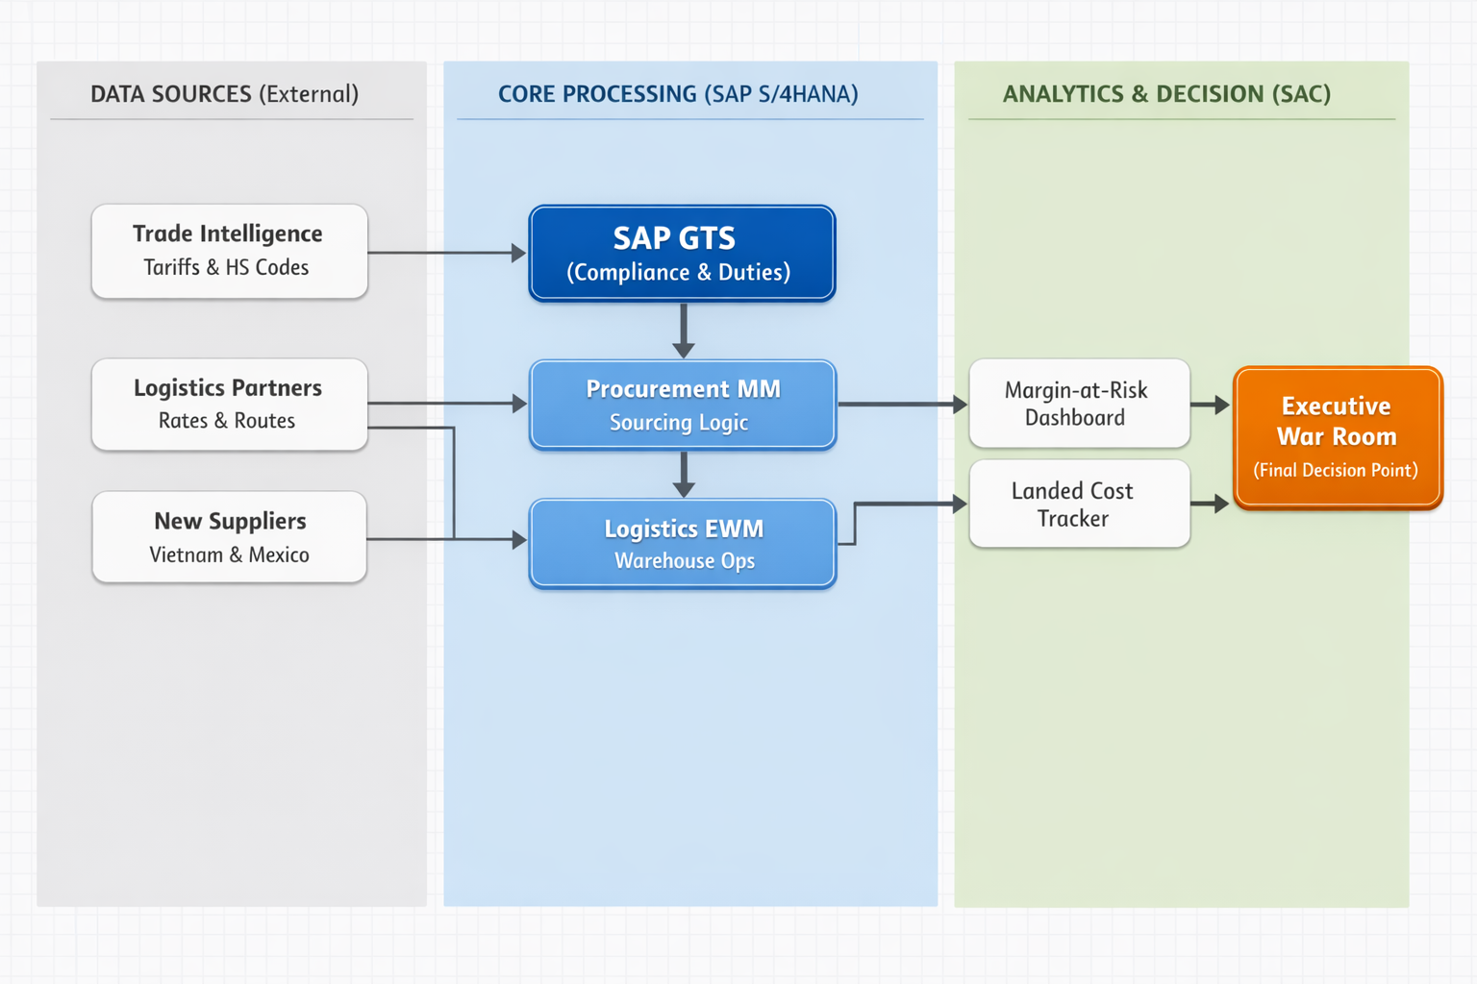

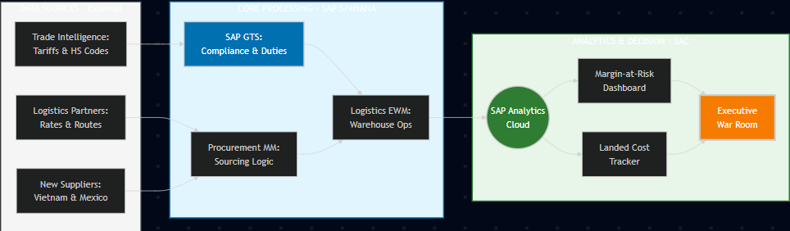

5. Functional requirements

ID | Requirement Description | Priority (High/Med/Low)

FR-01 | Automate tariff classification and gümrük compliance processes by deploying SAP GTS.1 | High
FR-02 | Implement SAP Analytics Cloud (SAC) dashboards to monitor real-time tariff intelligence and landed cost fluctuations.1 | High
FR-03 | Provide analytical capability to enable proactive pricing adjustments necessary to protect the organization's 35% gross margin target.1 | High
FR-04 | Systematically manage the transition of 40% of production volume to alternative manufacturing hubs in Vietnam and Mexico.1 | High
FR-05 | Ensure the system leverages existing trade agreement data (e.g., USMCA) to bypass import duties on eligible goods.1 | High

6. Solution components

Application Components:
- SAP Global Trade Services (GTS): The central engine for automated customs management, HS code classification, and ensuring compliance with shifting international trade regulations.
- SAP S/4HANA Procurement (MM): Responsible for managing the "Sourcing Logic," onboarding new suppliers in Vietnam and Mexico, and executing purchase orders under optimized trade terms.
- SAP Analytics Cloud (SAC): The primary platform for data stories, predictive modeling, and real-time visualization of financial impacts caused by tariff fluctuations.
- SAP Extended Warehouse Management (EWM): Manages inventory positioning within duty-free zones and bonded warehouses to defer or reduce tax liabilities.
Data Components:
- External Trade Intelligence Feed: API-driven data streams providing real-time updates on global tariff rates, duty draw-backs, and geopolitical trade shifts.
- Integrated Landed Cost Data Model: A unified data structure that combines base product costs with dynamic variables such as freight, insurance, and the 15%–25% tariff adjustments.
- Supplier Risk & Performance Metadata: Real-time data sets tracking the reliability and lead-time stability of new sourcing hubs in Southeast Asia and North America.
Infrastructure Components:
- SAP Business Technology Platform (SAP BTP): The integration layer that orchestrates secure data flow between the S/4HANA core, GTS compliance, and SAC analytics.
- Cloud Connector: A secure link ensuring seamless and encrypted communication between on-premise data environments and the SAP cloud ecosystem.
- Scalable Cloud Infrastructure: High-availability server environment designed to handle large-scale data processing for global supply chain simulations.
User Interfaces:
- Executive War Room Dashboard: A high-level SAC interface providing the "Single Source of Truth" for leadership to monitor gross margin health and strategic pivots.
- Margin-at-Risk Simulator: An interactive tool for pricing analysts to model "What-if" scenarios and determine optimal price adjustments based on varying duty levels.
- Compliance & Logistics Monitor: An operational Fiori-based interface for trade specialists to track customs clearance status and documentation accuracy.
- Mobile Alert System: Real-time notifications for procurement officers regarding supply chain bottlenecks or sudden regulatory changes.

